| Input | Desired Outcome | Processing | Solution / Alternatives |
| --- | --- | --- | --- |
| Age | Determine if applicant meets minimum age or not | - If age < 0 → Invalid Age - If age < 18 → Ineligible - If age ≥ 18 → proceed to next step | - Stop program if invalid or underage - Otherwise continue to next step |
| Eyesight Test Result (P/F) | Ensure applicant’s eyesight meets required standards | - If F → Need prescription for glasses - If P → proceed | - Stop program if failed - Continue if passed |
| Written Test Result (P/F) | Ensure applicant understands road rules | - If F → Give a retake - If P → proceed | - Stop program if failed - Continue if passed |
| Driving Test Result (P/F) | Ensure applicant can drive safely | - If F → Ineligible because you have not passed driving test - If P → proceed | - Stop program if failed - Continue if passed |
| Medical Certificate (Y/N) (only if age ≥ 60) | Confirm medical fitness for older applicants | - If N → Not eligible - If Y → Eligible | - Stop program if no certificate - Continue if yes |

**PAC CHARTS:**

**IPO CHARTS:**

| **Input** | **Processing** | **Output** |
| --- | --- | --- |
| - Age - Eyesight test (P/F) - Written test (P/F) - Driving test (P/F) - Medical certificate (Y/N if ≥60) | - Validate age - Check test results - If age ≥60 check medical certificate - Decide eligibility accordingly | - Invalid Age!! - Ineligible!! - Need prescription for glasses!! - GIVE A RETAKE!! - Ineligible because you have not passed the driving test. - You are eligible for the license - Not eligible - Eligible!! |

**ALGORITHM:**

1. **Start**
2. **OUTPUT "DRIVING LICENSE FORM"**
3. **OUTPUT “Enter your age:"  
   Input age**
4. **If age < 0  
   OUTPUT “Invalid Age!!"  
   Stop**
5. **If age < 18  
   OUTPUT "Ineligible!!"  
   Stop**
6. **OUTPUT "Have you passed the eyesight test? (Press P for pass and F for fail):"  
   Input Eyesight_exam**
7. **If Eyesight_exam = 'F'  
   OUTPUT “Need prescription for glasses!!"  
   Stop**
8. **OUTPUT “Have you passed the written test? (Press P for pass and F for fail):"  
   Input written_test**
9. **If written_test = 'F'  
   OUTPUT"GIVE A RETAKE!!"  
   Stop**
10. **OUTPUT "Have you passed the driving test? (Press P for pass and F for fail):"  
    Input driving_test**
11. **If driving_test = 'F'  
    OUTPUT "Ineligible because you have not passed the driving test."  
    Stop**
12. **If age < 60 then  
    OUTPUT "You are eligible for the license"  
    Stop**
13. **Else (age ≥ 60):  
    OUTPUT "Do you have a medical fitness certificate? (Press Y for yes and N for No):"  
    Input medical_certificate**
14. **If medical_certificate = 'N'  
    OUTPUT "Not eligible"  
    Stop**
15. **Else  
    OUTPUT "Eligible!!"  
    Stop**
16. **End**

**FLOWCHART:**

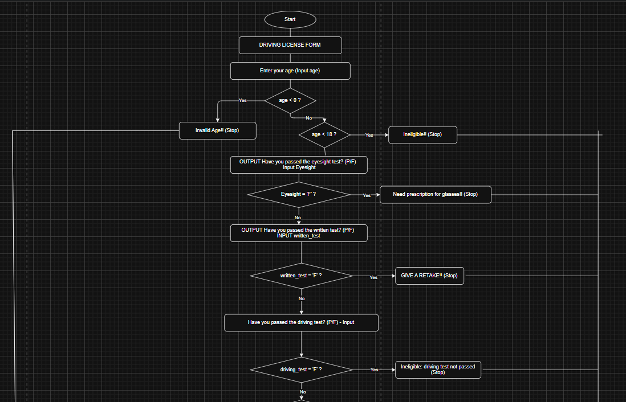

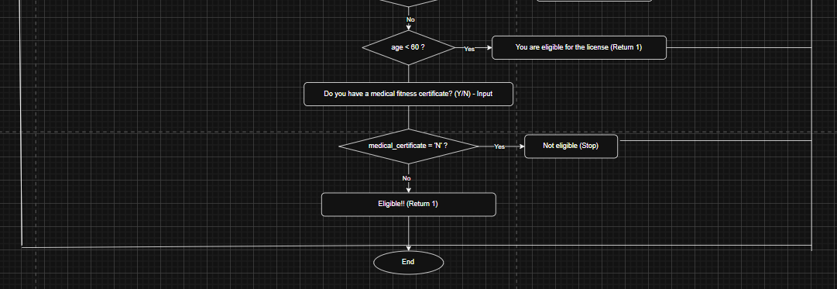

**PSEUDOCODE:**

DECLARE Eyesight_exam, written_test, driving_test, medical_certificate AS CHAR

DECLARE age AS INTEGER

OUTPUT("DRIVING LICENSE FORM")

OUTPUT("Enter your age: ")

INPUT(age)

IF age < 0 THEN

OUTPUT("Invalid Age!!")

RETURN -1

ENDIF

IF age < 18 THEN

OUTPUT("Ineligible!!")

RETURN -1

ENDIF

OUTPUT("Have you passed the eyesight test? (Press P for pass and F for fail): ")

INPUT(Eyesight_exam)

IF Eyesight_exam = 'F' THEN

OUTPUT("Need prescription for glasses!!")

RETURN -1

ENDIF

OUTPUT("Have you passed the written test? (Press P for pass and F for fail): ")

INPUT(written_test)

IF written_test = 'F' THEN

OUTPUT("GIVE A RETAKE!!")

RETURN -1

ENDIF

OUTPUT("Have you passed the driving test? (Press P for pass and F for fail): ")

INPUT(driving_test)

IF driving_test = 'F' THEN

OUTPUT("Ineligible because you have not passed the driving test.")

RETURN -1

ENDIF

IF age < 60 THEN

OUTPUT("You are eligible for the license")

RETURN 1

ELSE

OUTPUT("Do you have a medical fitness certificate? (Press Y for yes and N for No): ")

INPUT(medical_certificate)

IF medical_certificate = 'N' THEN

OUTPUT("Not eligible")

RETURN -1

ELSE

OUTPUT("Eligible!!")

RETURN 1

ENDIF

ENDIF

**C CODE:**

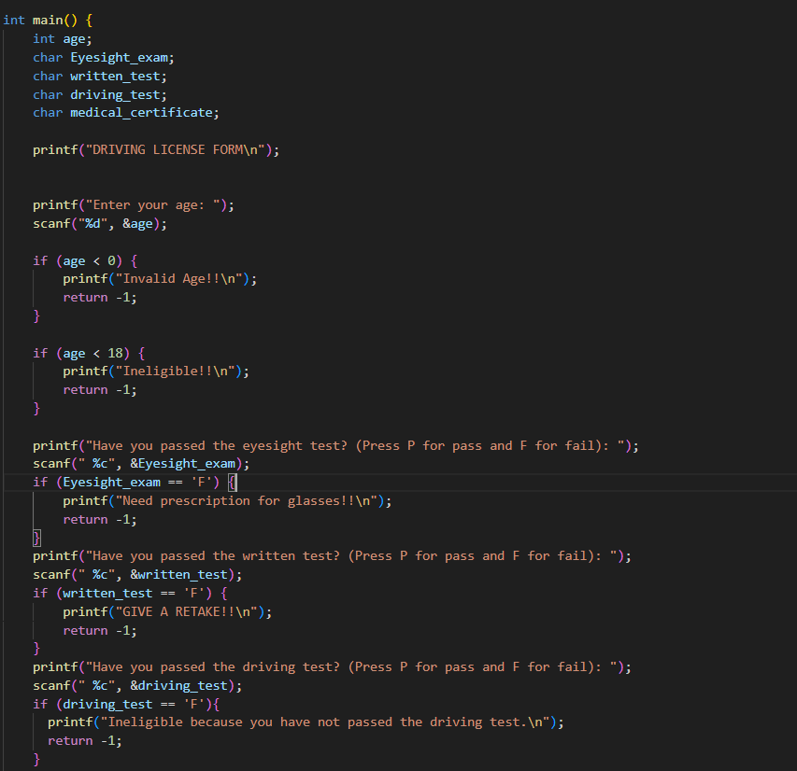

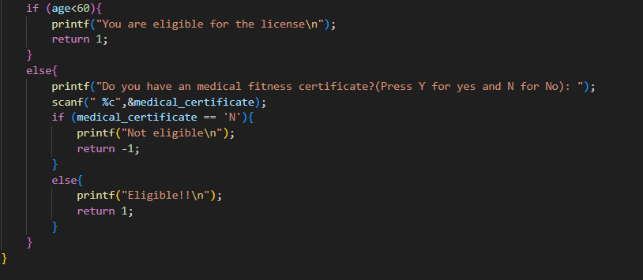

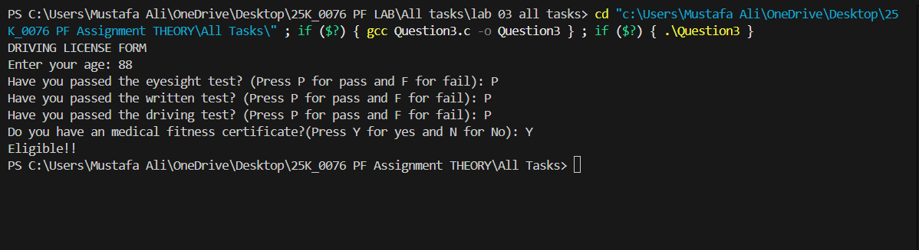

**PSEUDOCODE:**

DECLARE Eyesight_exam, written_test, driving_test, medical_certificate AS CHAR

DECLARE age AS INTEGER

OUTPUT("DRIVING LICENSE FORM")

OUTPUT("Enter your age: ")

INPUT(age)

IF age < 0 THEN

OUTPUT("Invalid Age!!")

RETURN -1

ENDIF

IF age < 18 THEN

OUTPUT("Ineligible!!")

RETURN -1

ENDIF

OUTPUT("Have you passed the eyesight test? (Press P for pass and F for fail): ")

INPUT(Eyesight_exam)

IF Eyesight_exam = 'F' THEN

OUTPUT("Need prescription for glasses!!")

RETURN -1

ENDIF

OUTPUT("Have you passed the written test? (Press P for pass and F for fail): ")

INPUT(written_test)

IF written_test = 'F' THEN

OUTPUT("GIVE A RETAKE!!")

RETURN -1

ENDIF

OUTPUT("Have you passed the driving test? (Press P for pass and F for fail): ")

INPUT(driving_test)

IF driving_test = 'F' THEN

OUTPUT("Ineligible because you have not passed the driving test.")

RETURN -1

ENDIF

IF age < 60 THEN

OUTPUT("You are eligible for the license")

RETURN 1

ELSE

OUTPUT("Do you have a medical fitness certificate? (Press Y for yes and N for No): ")

INPUT(medical_certificate)

IF medical_certificate = 'N' THEN

OUTPUT("Not eligible")

RETURN -1

ELSE

OUTPUT("Eligible!!")

RETURN 1

ENDIF

ENDIF